Chara Kolokytha

Jacques [Chaïm Jacob] Lipchitz (1891-1973)

Jacques Lipchitz is considered to be one of the first cubist sculptors in France along with Henri Laurens. A Lithuanian born sculptor naturalised in France, Lipchitz trained in Paris at the École des Beaux Arts and the Académie Julian. During the Second World War he moved to the United States and remained in New York until 1963 when he returned to Europe to settle in Capri, Italy, until his death.

Lipchitz’s early work was largely influenced by Pablo Picasso’s early cubist compositions (Baigneuse III, plaster, 1917) and Brancusi’s simplified geometrical volumes in addition to early archaic and classic art (Tête de fillette and Pregnant Woman, 1911-12). In the early 1920s he created a series of bas reliefs influenced by cubism and African art commissioned by the collector Albert Barnes (Nature morte aux instruments de musique, 1924). During this decade, Lipchitz became concerned that his sculpture was becoming too abstract; in order to counter it, he began to place emphasis on the subject matter of his works. His work Le Couple (1929), which represents a man and a woman engaging in sexual intercourse, was attacked by critics for being much too uninspired and commonplace so that the artist later renamed it Le Cri (The Cry).

Lipchitz’s late work was based on mythological (L'Enlèvement d'Europe, 1938) and biblical themes (La Lutte de Jacob avec l'ange, 1931) while his style demonstrated the influence of Auguste Rodin’s impressionist style with several references to the baroque tradition. During the Second World War his work became autobiographical with several symbolic references. After the war he worked on monumental commissions of religious or historical importance in France (Notre-Dame de Liesse, 1948) and the United States (Spirit of Enterprise, 1960).

Films
Lipchitz in the Gardens of the Palais Royal, ina.fr (French)
http://fresques.ina.fr/europe-des-cultures-fr/fiche-media/Europe00259/jacques-lipchitz-aux-jardins-du-palais-royal.html

List of works

Baigneuse III (Bather III), plaster, 1917, MNAM - Centre Pompidou, Paris

Tête de fillette (Woman’s head), plaster, 1911-12, Tate Gallery, London.

Pregnant Woman, plaster, 1911-12, Tate Gallery, London.

Nature morte aux instruments de musique (Still life on music instruments), 1924, Tate Gallery, London.

Le Couple (The Couple), plaster, 1929, Kröller-Müller, Otterlo.

L'Enlèvement d'Europe (The rape of Europe), bronze, 1938, MNAM – Centre Pompidou, Paris.

La Lutte de Jacob avec l'ange (Jacob and Angel), plaster, 1931, Tate Gallery, London.

Spirit of Enterprise, bronze, 1960, Fairmouth Park, Philadelphia.

References and further reading

Raynal, M. (1920) Jacques Lipchitz, Paris, Action ; (1947) Jacques Lipchitz, Paris, J. Bucher.

Lipchitz, J. (1954) Amadeo Modigliani (1884-1920), Paris, Flammarion.

Lipchitz, J. (1972) My Life in Sculpture, New York, Viking Press.

Hammacher, A. M. (1975) Jacques Lipchitz Biography, New York, Abrams.

Stott, D. (1978) Jacques Lipchitz and cubism, London, Garland.

Wilkinson, A., Hammacher, A. M. (1996-2000) The sculpture of Jacques Lipchitz: a catalogue raisonné, London, Thames and Hudson.

Putz, C. (2002) Jacques Lipchitz: The first cubist sculptor, London, Paul Holberton Pub.

Posèq, A. W. G. (2006) Jacques Lipchitz, maker of Jewish sculpture, Jerusalem, Academon.

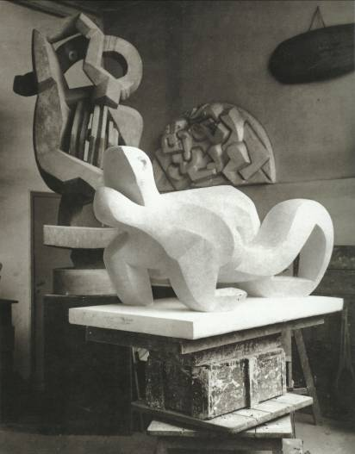

Lipchitz’s studio. Le Couple, plaster, 1928-9 and Pastor, background. Reproduced in Cathy Putz, Jacques Lipchitz: The first cubist sculptor, Paul Holberton, 2002.

